# INTRODUCTION

* 1. Overview
  2. Administrator should be able to create all base data including Semester, Candidate,Course and Lecturer .Lecturer should have the ability to create Internal Results,Dean,who is one of the Lecturer, should be the only one with ability to update InternalResults,Re-evaluation Can be initialised by Candidate for all Internal Results.Now only dean can update the marks after re- evaluation

A brief description about our project

Administrator should be able to create all base data including Semester, Candidate, Course and Lecturer.

Lecturer should have the ability to create Internal Results Dean, who is one of the Lecturer, should be the only one with ability to update Internal Results Re-evaluation Can be initialised by Candidate for all Internal Results. Have a multilevel approval process for the re-evaluation of the internal marks, 1st level by lecturer and 2nd level by dean. Now only dean can update the marks after re- evaluation Dean should be able to see list of Candidates grouped by Marks (Pass / Fail) in each Semester – should be a VisualForce page. Dean should be able to see average percentage of each Course for a Candidate. Dean should have the ability to view Pass percentage for each Semester.

* 1. Purpose
  2. This Project helps in Tracking the result of a candidate with Internal Marks

The use of this project. What can be achieved using this.

* It can track results and internal marks of the candidates
* This is help to record the internal results
* Send internal results via email and SMS
* We can generate report of candidate’s internal marks.
* Continuous evaluation of candidate performance
* The system is based on cloud platform and offers high security of the data
* The system offers restricted login to faculty members base on their position

1. **Problem Definition & Design Thinking**
   1. Empathy Map

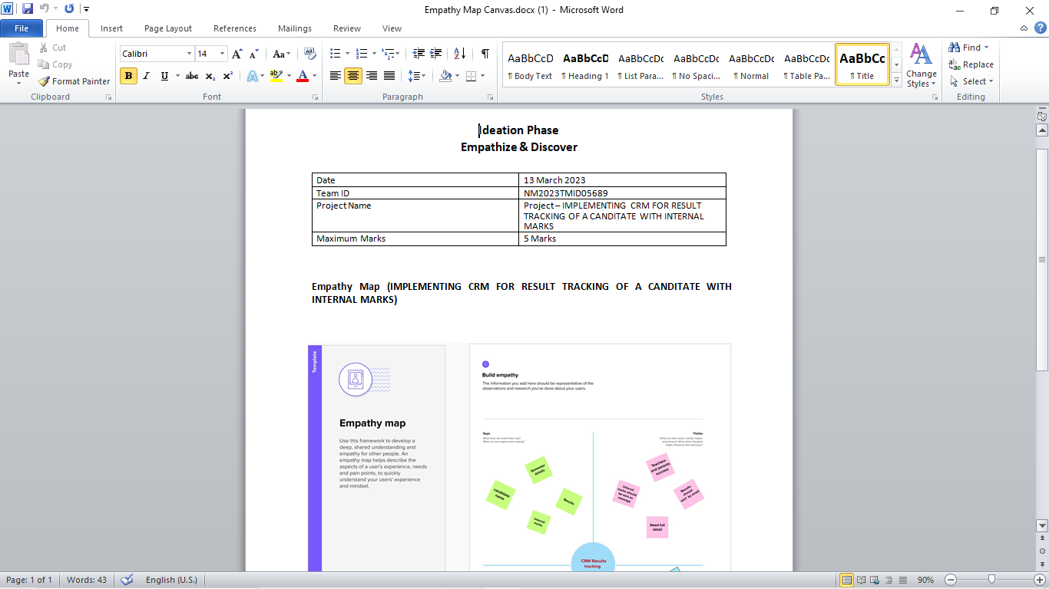

* 1. Ideation & Brainstorming Map

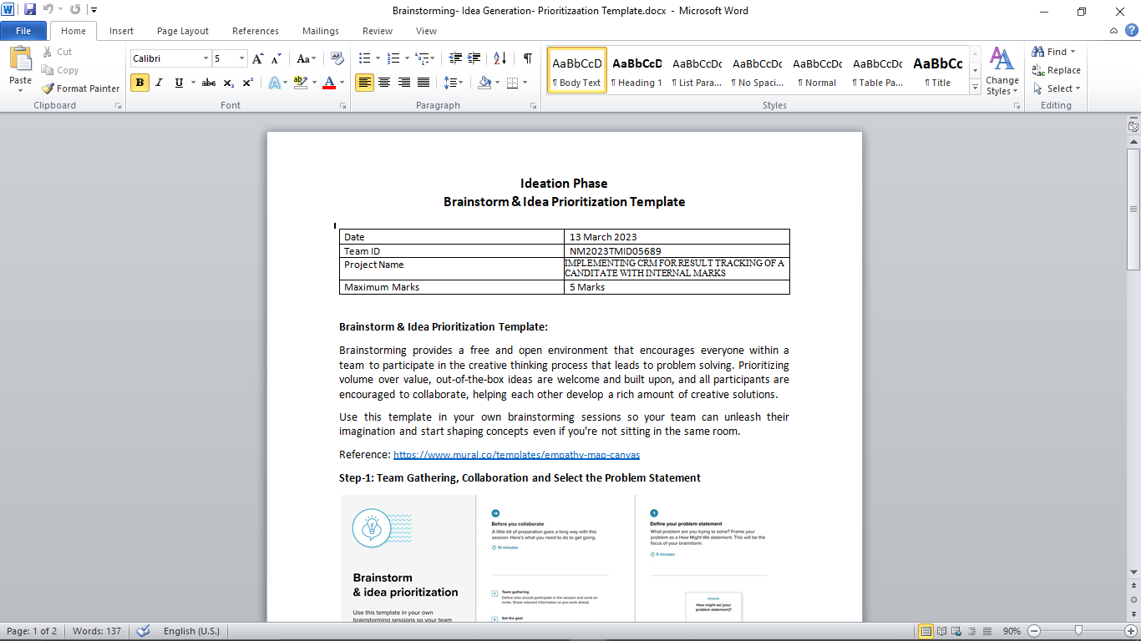

# RESULT

* 1. Data Model:

|  |  |
| --- | --- |
| Field label | Data type |
| City | Text |
| Phone number | Number |

|  |  |
| --- | --- |
| **Object name** | **Fields in the Object** |
| obj1  Semesters | |  |  | | --- | --- | | Field label | Data type | | Semester Name | Text | | Course Details | Lookup(course details) | |
| obj2  Candidates | |  |  | | --- | --- | | Field label | Data type | | Candidate Name | Text | | Candidate ID | Text | | Candidate Marks | Lookup(Internal Results) | | Semester Name | Text | |
| Obj 3  Course Details | |  |  | | --- | --- | | Field label | Data type | | Course Name | Text | | Course ID | Text | |
| Obj 4  Lecturer Details | |  |  | | --- | --- | | Field label | Data type | | Lecturer Role | Text | | Lecturer Name | Text | | Course ID | Text | | Course Details | Lookup(Course Details | |
| Obj 5  Internal Results | |  |  | | --- | --- | | Field label | Data type | | Candidate ID | Text | | Course ID | Text | | Marks | Text | |

## Activity & Screenshot

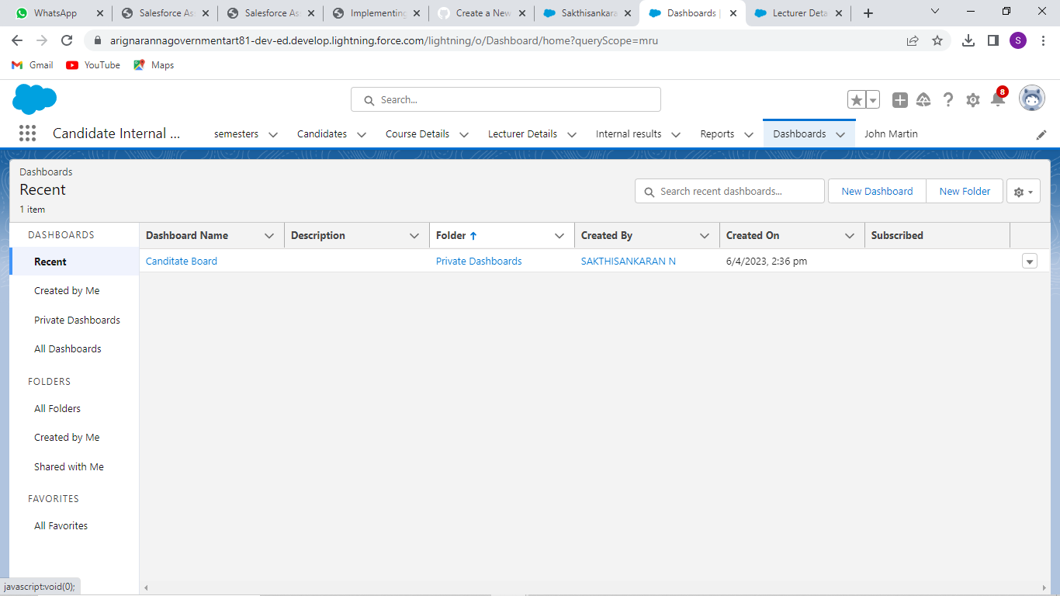

## Trailhead Profile Public URL

**Team Lead­-**[**https://trailblazer.me/id/sakthisankaran**](https://trailblazer.me/id/sakthisankaran)

**Team Member 1 -** [**https://trailblazer.me/id/mkandana**](https://trailblazer.me/id/mkandana)

**Team Member 2 -** [**https://trailblazer.me/id/abirs19**](https://trailblazer.me/id/abirs19)

**Team Member 3-**[**https://trailblazer.me/id/mvishnu26**](https://trailblazer.me/id/mvishnu26)

# ADVANTAGES & DISADVANTAGE

List of advantages

* designed to help you can easily to track exam results ,data ,internal results with in a second
* It helps you manage all the candidate-related data in a well-organized manner

List of disadvantages

* System is a complex user interface but that is not a big issue

# APPLICATIONS

* Staffs can able to monitor student progress in every stages
* Controller of exam section easily maintain the mark details

1. CONCLUSION

This Project helps in tracking the result of a candidate with Internal

Marks. Staffs and Dean can able to monitor all the students progress in

single platform.

# FUTURE SCOPE

It can be developed added some special options where the parents can able to access and monitor their children progress.